How to Use Svm_UI

1 Training
Click “Learning “ from Toolbar or Menu, a dialog will appears like following :
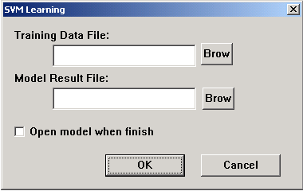
You can browse and choose the training sample data file(*.trn), or write the data file’s name into the text editor directly. And write down the training result data file(*.mdl). Then click “OK” to begin training .If you want to see training result after computation ,check the “Open model when finish” CheckBox.

Testing
Click “Classify “ from Toolbar or Menu, a dialog will appears like following:
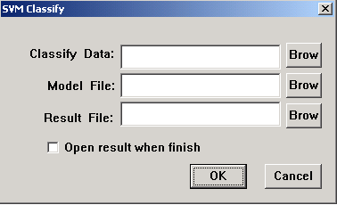
You can browse and choose the testing sample data file (*.tst), or write the data file’s name into the text editor directly. And write down the training result data file(*.mdl),test result file (*.rsl). Then click “OK” to begin training .If you want to see testing result after computation ,check the “Open result when finish” CheckBox.

File Format
The input file example_file contains the training examples. The first lines may contain comments and are ignored if they start with #. Each of the following lines represents one training example and is of the following format:
<class> .=. +1 | -1 | 0
<feature> .=. integer
<value> .=. real
<line> .=. <class> <feature>:<value> <feature>:<value> ... <feature>:<value>
The class label and each of the feature/value pairs are separated by a space character. Feature/value pairs MUST be ordered by increasing feature number. Features with value zero can be skipped. The +1 as class label marks a positive example, -1 a negative example respectively. A class label of 0 indicates that this example should be classified using transduction. The predictions for the examples classified by transduction are written to the file specified through the -l option. The order of the predictions is the same as in the training data.

Options
There are two types of options. One is for learning, such as kernel types, kernel parameters, etc; the other is for prompt information, such as show optimize information or not.

Learning Options:
To configure Learning Options, click “Learning Options” from toolbar /menu, a dialog will appear like following:
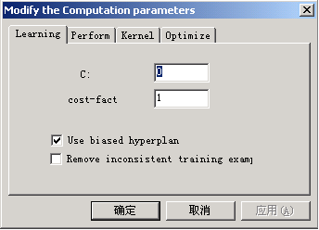
You can set the learning parameters at this dialog. Particularly, you can choose kernel type at the dialog page following:
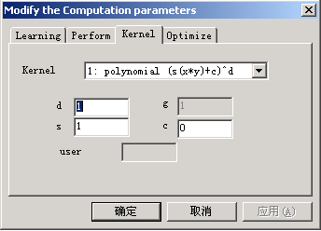

Prompt Options
To configure Learning Options, click “Prompt Options” from toolbar /menu, a dialog will appear like following:
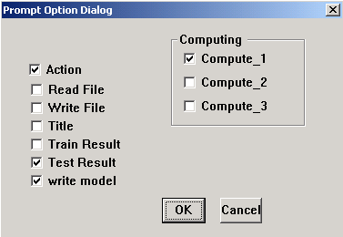
A little ugly? //sigh. I will improve it in next version. You can select the information you want to see when computing .You can modify this option even when computing. It is lucky that I didn’t write a single code for synchronization (Incredible?)

